Capstone project -The battle of the neighborhood

Discution of the problem

The project will deal with the problem of environmental pollution with pm2.5 and pm10 dust in Krakow (Poland). Krakow is one of the largest cities in Poland, inhabited by about 1 million inhabitants. Because of its location in the basin and the density of population – it’s one of the most polluted cities in Europe.

The project shows the location on the map of sensors measuring the air condition. Then the city area is divided into clusters to check whether the degree of pollution depends on the location of the sensors. It will be checked also if one boroughs are more polluted than another and whether the degree of pollution depends on the time of day.

Data – csv files from Kaggle.

Data contain information of the location (latitude and longitude) of approximately 50 sensors located within the city. I assigned localization to each sensor (zone). There are 5 zones: old town, ES, EN, WN, WS.

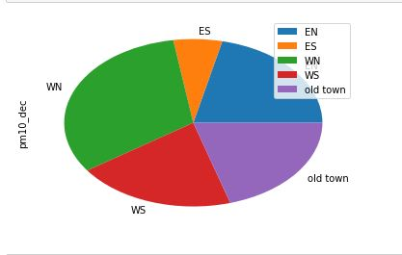

There are also values recorded by each sensor (temperature, humidity, pm 10, pm2.5, pm1) for each day of 2017 every one hour. Because of the huge amount of data it will be taken only pm10 and pm2.5 information for day in December and one day in July to show the difference in air pollution depending on the season. We can see that in July there is lower pollution than in December.
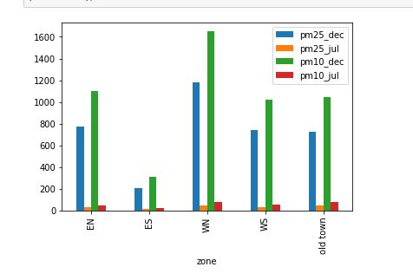

Then I created the map of Krakow with the sensors location. Next step was clusterization and using Foursquere. We can see the map of krakow with sensors clusters by the zones (on the map csensors are in different colors – depend on the zone where are located). I used Foursquere to find the venues for different clusters. We can see the most popular places for each cluster.

